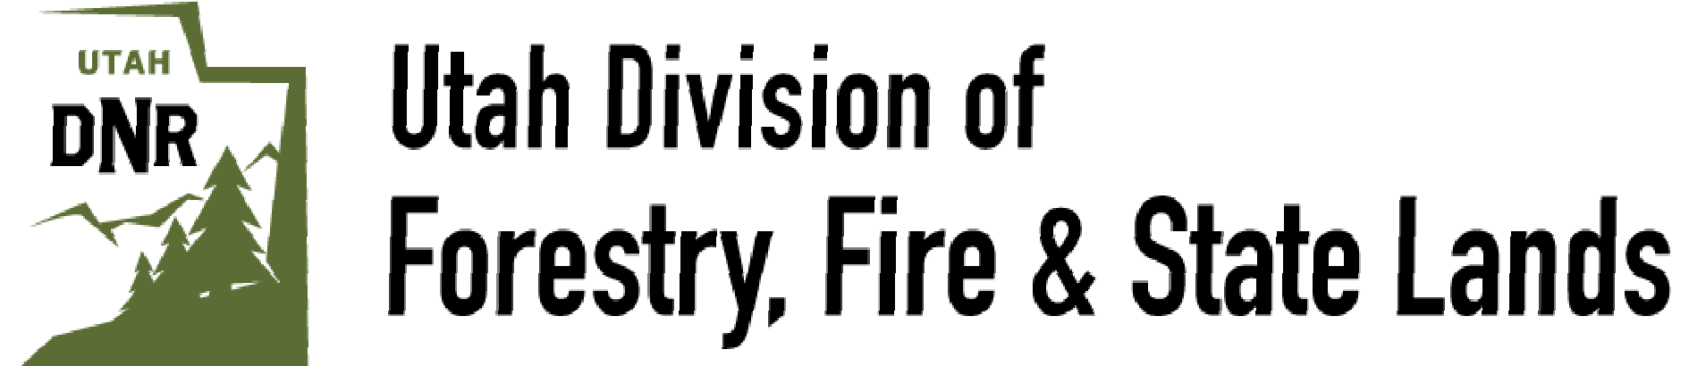

Assistant WUI Coordinator Position

**Summary**

The Assistant WUI Coordinator will coordinate fuels reduction projects in communities throughout Southeast Utah. This position will work in a variety of forest types, from desert riparian forests all the way up to subalpine forests, performing fuels reduction work across our area. This position works with a team that includes the Area WUI Coordinator, and the seasonal WUI crew.

**Season**: This is a year-round benefitted position that is grant dependent.

**Duty Office:** Moab, UT

**Wage:** $18.50 - $27.47

**Application Deadline:** February 3rd. **Start Date:** Early March

**To apply please send resume, references, and optional cover letter to** [**johnwiegand@utah.gov**](mailto:johnwiegand@utah.gov)

# Position Overview

The Utah Division of Forestry, Fire, and State Lands is looking for an organized, independent, professional individual to implement projects throughout Southeast Utah. This position reports to the Southeast Area WUI Coordinator who is also based out of the Moab office.

The Assistant WUI Coordinator’s mission is to prevent homes and sensitive landscapes from being damaged or destroyed in catastrophic wildfire. This individual will achieve this mission through outreach to landowners, grant writing, fire prevention campaigns, and fuels reduction project implementation. The Assistant WUI Coordinator is generally given great leeway to determine the best actions to take to accomplish their goals, but is there primarily to assist the WUI Coordinator implement the WUI program in SE Utah. The Assistant WUI Coordinator, when not on fuels reduction projects, may participate in:

* Fire suppression operations
* Forestry projects
* Prescribed fire operations
* Noxious weed treatment

The Assistant WUI Coordinator will work closely with landowners, HOAs, and local municipalities to coordinate fuels reduction work as well as spread fire prevention and mitigation messaging. This position also works closely with city, county, state and federal and non-profit project partners to accomplish common goals.

This position works very closely with the Area WUI Coordinator and will be given plenty of guidance and training.

A typical work week will be Monday-Thursday (10-hour days). Some time out of town will be required depending on meetings, and project schedules. Typically, this individual will spend 1-2 work weeks away from town during the busy season. Both the WUI Coordinator and Assistant have somewhat flexible schedules due to meetings and other duties outside of normal work hours, but can be flexible around personal schedules.

# Trainings we will provide

* Firefighter Type 2 Crewmember (FFT2)
* Wildland Fire Chainsaw (S-212/FAL3)
* First Aid CPR

Successful completion of an annual arduous level pack test is required every spring.

Fire suppression time will vary depending on the ability and skill level of the individual. There are possibilities to go on local initial attack, 2-week hand crew or engine assignments, and Incident Team Assignments, depending on the qualifications and interest of the individual. Fire suppression time is not emphasized in the job but prescribed fire participation will be.

# Duties and Responsibilities

* Supervise and train a 5-person fuels crew
* Perform outreach to communities throughout Southeast Utah
* Perform home ignition assessments
* Design fuels reduction projects for maximum benefit to communities and landscapes
* Identify funding sources for planned projects
* Write and apply to grant funding sources
* Implement fuels reduction projects via contracting or fuels crew
* Track grant expenses and adhere to grant guidelines
* Participate in grant ranking committees
* Participate in all parts of the fuels crew operations
* Coordinate meetings and write Community Wildfire Preparedness Plans
* Fly drones to capture project and landscape level imagery
* Use ArcGIS to create field maps for contractors and fuels crew
* Coordinate with agency partners including government agencies, and non-profits
* Participate in prescribed fire operations including pile burns and broadcast burning

# Required Qualifications

* 1-4 seasons in a field level position in natural resources.
* Ability to manage paperwork and prioritize work based on funding and deadlines.
* Personable and able to communicate with people of different backgrounds.
* Ability to resolve interpersonal conflict professionally on crews and with landowners.
* Ability to hike steep terrain.
* Ability to work and camp on remote sites for up to 4 days.
* Ability to drive large trucks with heavy trailers.
* Valid Driver’s license

# Desired Qualifications

* Bachelor degree in related natural resource field
* Knowledge of regional riparian and forestry systems
* Prescribed fire experience with relevant qualifications
* FFT2 or better
* FAL3 or better
* Herbicide Applicator License
* Part 107 FAA License

# Employee Benefits

* Annual leave accrued at 4 hours/2 weeks
* Sick leave accrued at 4 hours/2 weeks
* Paid Holidays
* Medical, Dental, and Vision insurance plans
* 10% retirement contributions
* Up to $79/day per diem when camped on work sites
* Up to 3 hours of PT/week
* Camping gear provided

This position also has significant opportunity for training:

* Part 107 FAA Drone License
* Fire Operations in the Wildland/Urban Interface (S-215)
* ArcGIS training
* Basic Air Operations (S-270)
* Relevant conferences and classes as approved by supervisor
* Herbicide Applicator License
* There is significant leeway for training in whatever the individual is interested in

This is an excellent position for someone looking to take the next step in their career. With the right attitude and motivation any individual could be successful in this job. Our goal is to train this individual so that they can be successful in higher positions within FFSL.